Pros and cons of random gen event placements vs Multi floor layouts.

Pros of Random gen placement

-Much more variety in floor layouts

-More replayability

-More complexity

Cons of Random gen placement

-More difficulty programming the events to make it place the events randomly

-Can be an issue with the amount of calculations that need to be done

-Time constraints

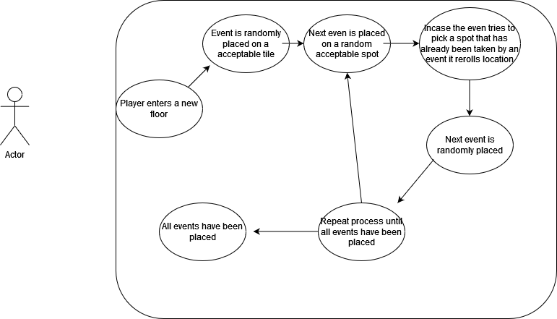

Pros of Multi Floor Layouts

-More difference in designs for floors

-Faster to develop for the game

-More uniqueness for the player to look at

Cons of Multi Floor Layouts

-Will get repetitive quicker

-Less complexity

-Players can memorise layouts

